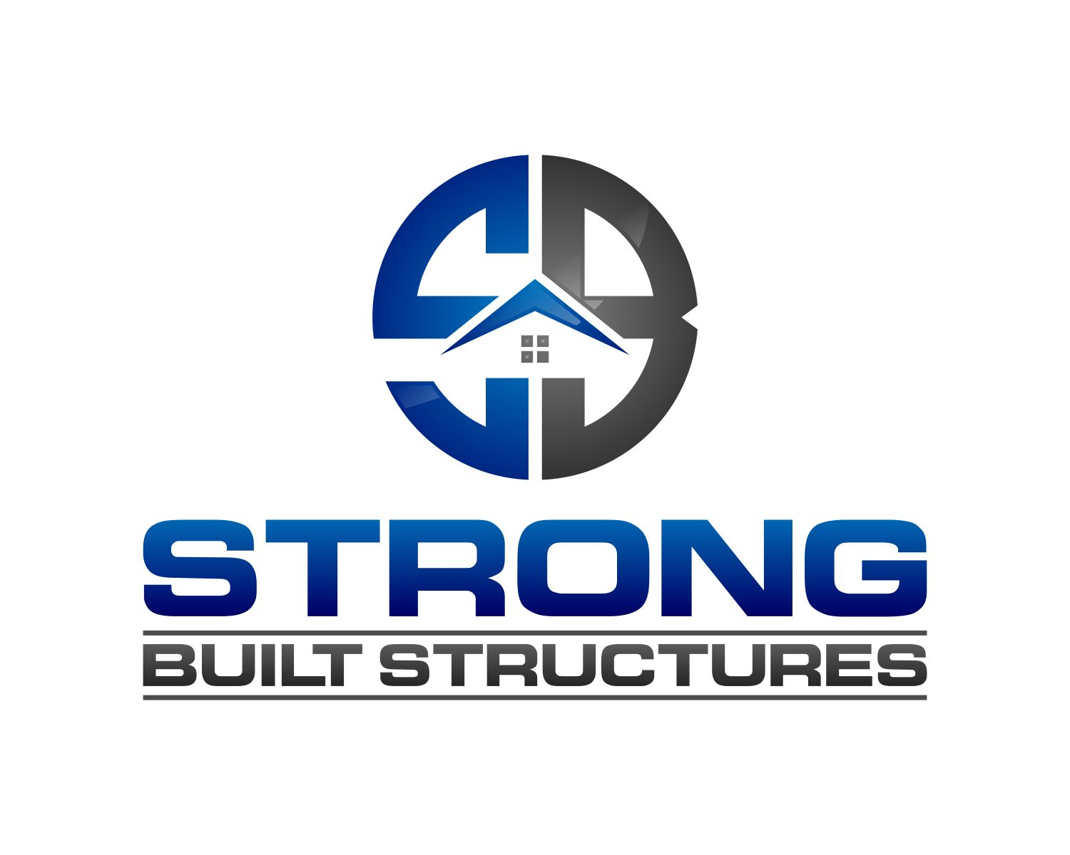

***BUILT TO LAST!***

Why **StrongBuilt**?

The StrongBuilt system is unique; in that it provides an incredibly strong structure that is:

* Built to last
* Durable
* Earthquake Resilient
* Energy Efficient
* Fire Resistant
* Hurricane Resistant
* Tornado Resistant
* Uncompromised Safety

All while being cost effective and affordable. The StrongBuilt system can be used to make structures that range from simple saferooms and safe suites, to multi storied buildings.

If you are looking for a saferoom, or a safe home, a StrongBuilt Structure is your solution.

What is **StrongBuilt**?

StrongBuilt is a patented, high-performance concrete building system. We start with a specially designed insulating foam panel. The foam panel is reinforced with stainless steel welded wire mesh on both sides of it. The layers of mesh connect to each other through the foam panel with welded wire. Then we cast our special, high performance, concrete mix on both sides of the foam panel. This creates an airtight, and high strength system that is used to monolithically cast the walls and ceilings of a structure. The roofs can also be made using the system.

Energy Efficiency

The StrongBuilt System is very energy efficient. The system can be designed to have R-Values ranging from R14 to R38. By having a layer of our high-performance concrete on the interior, conditioned side of the structure, our system has a very low U-factor. This means that once a room is at the desired temperature, it will stay there for a longer period of time. The result is that your strong built structure will require less energy to heat and cool; saving you money.

* U-factors generally range from **0.2** (very little heat loss) to **1.2** (high heat loss). The U-factor is the inverse of the R-value, which measures insulating value.

Strength

The StrongBuilt system has been tested at independent laboratories for the following:

* **Ballistics tested** (in accordance with ANSI/UL 752-05)
* **Blast tested** (testing performed by Baker Engineering and Risk Consultants, Inc.)
* **Earthquake tested** (full scale testing performed at CUPC Anti-Seismic Structure Laboratory in Peru)
* **Flying debris (missile impact tested)** in accordance with ICC 500 Section 305.1.1 and 305.1.2.
  + This exceeds the estimated wind speed for an EF5 tornado.
  + This exceeds the sustained wind speed for a category 5 hurricane.

The **StrongBuilt** story

Company founder, Jeff Manning, was trying to solve the housing shortages in the oil patch. He visited many areas in Western Texas to assess the need first hand. The lack of available workforce in these areas prompted him to consider building livable structures off site; where labor was available. These structures needed to be both durable and energy efficient; to withstand the harsh environments where a lot of the oil patches are located. Traditional manufactured housing could not stand up to the forces mother nature exerted in the desert environments of West Texas. Jeff knew that he could come up with a sustainable, housing solution.

Jeff relied upon his many years’ experience in the construction industry. He knew concrete is extremely durable, and structures built out of concrete lasted hundreds, even thousands of years. It also holds temperatures well. He thought precast concrete modules, the size of standard hotel rooms, may be the solution. The modules would be cast in areas where labor was readily available and more affordable. These modules would have to be able to withstand the abuse of being shipped hundreds of miles, the wear and tear of the men who would live in them, and the abuse that mother nature regularly exerted; high winds, extreme temperatures and tornados.

After calculating the weight of precast concrete units, Jeff quickly realized why the concept hadn’t already been used. Using the conventional technology of the time, the concrete modules would be far too heavy to ship. His idea to precast concrete rooms would have to be completely rethought, and new technologies found; to make a precast structure of this size, viable. He worked with structural engineers, and experts in the concrete industry, to come up with a solution to make precast concrete modules that would be extremely durable, energy efficient and light enough to ship across country. The end result is a truly revolutionary construction system. The StrongBuilt system exceeds all of the needed attributes to make Jeff’s goal, a reality.

Once the engineering was completed and the system proven buildable, Jeff quickly realized that the strengths designed into the system, that allowed the concrete modules to be shipped across country, also made them extremely resilient to the forces of mother nature and man-caused catastrophes. The system’s performance exceeded Jeff’s initial goals and can be used to construct any structure that needs to protect people or other high valued assets. The uses range from saferooms to multi-storied military barracks. Now houses are being designed utilizing the StrongBuilt system. They will provide their owners with the peace of mind that they are safe in their home, and saving money every month with lower energy costs.

Jeff’s vision is that anyone desiring an energy efficient, safe place to live, work or play, will choose the **StrongBuilt** system for their next project.

**SAFEROOMS TAB**

***Strong Built Saferooms***

***A true “Safe Room”, That’s large enough to live in***

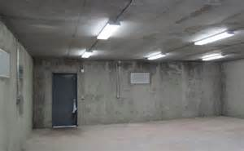 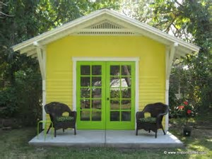

***Large Saferoom Saferoom Cottage***

“*Everyone should be able to feel safe in their home*. *Now I do, with the addition of my* ***StrongBuilt*** *saferoom*,” Nilaree Manning.

**Why have a StrongBuilt saferoom?**

Safety is not something that should be questioned. You have the right to feel as if nothing can get in the way of your ability to protect your family, including a storm. Mother Nature can be brutal, and often times is. When it is up to you to choose what is best for your families’ protection, a safe room by StrongBuilt Structures is always the superior option.

When you purchase a safe room by StrongBuilt Structures, you are not just ensuring your family's safety, you may be saving their lives, and your own. With our design, you will not only be able to ride out the most brutal storms, but you will be able to do so comfortably. Your structurally sound safe room also adds to your living space when you choose the option of attaching it to your existing home.

While safety is so important, it is often inconvenient and unaffordable. Why should you have to go through lengths to protect your loved ones? Simple, you shouldn't. When you purchase a StrongBuilt Structure, we transform the radical illusion that safety has to be difficult, and strive to make installation an easy and affordable process. In total convenience to you, your safe room is built right on your property, and can be attached to any existing home.   
  
     StrongBuilt Structures are also unlike any other advertised safe rooms. Our design is not only stronger and more durable, but you can also have confidence that that your investment will be well worth it. Apart from the standard safe room; that is significantly smaller, and only useful in dire situations, a StrongBuilt Structure actually adds to your living space!   
  
     You deserve honest protection that is not only there to guarantee your safety, but also provides livable space that will be of use even on those bright and sunny days. With even a possible 20x21ft. design optional to be attached to your home or placed in an outside area of your choice, our safe rooms are anything but a bad investment. Your insulated safe room can also be fitted with a bathroom, kitchenette, and other standard household utilities. Custom add-ons like shingled rooftops and outside cladding are also available, to make your safe room feel just like home.

The safest place in your home should provide you with honest security and protection. That place is not in the bathtub or under a mattress. That place is in your safe room, out of harm's way, and far from danger; with all of the comforts of home. We provide a large insulated space that can even be fit with standard household utilities. Imagine, being able to walk into your safe room like it is any ordinary part of your home, but knowing it could save your life in a dire situation.

We beat our competitors with safe rooms that are larger and stronger. Instead of semi-safe closet-like spaces, that barely increase the value of your home, we raise the bar with ultimate protection and large spaces. All of our saferooms come standard with 9’ ceilings. Dimensions range from 10’x10” to 20’x40. This means your StrongBuilt saferoom is a real room. Customers also use their StrongBuilt saferoom as a quest suite, a place for mom, or mancave. With easy on-site installments that are budget friendly, the only question you'll have is, why you don't own one already.

**USING ITS PATENTED, ULTRA-HIGH PERFORMANCE CONCRETE SYSTEM, STRONG-BUILT STRUCTURES CONSTRUCTS SAFE ROOMS THAT ARE LARGE ENOUGH TO LIVE IN.**

**THE BENEFITS OF OUR PATENTED HIGH PERFORMANCE CONCRETE SYSTEM:**

* **A StrongBuilt Saferoom addition or guest cottage, adds usable living space to your existing home.**
* **An addition may be used as a new media room or home office.**
* **A detached saferoom can be used as a quest cottage, studio or workshop.**
* **Its easy to add personal details such as covered porches, pitched roofs, brick or rock.**
* **Sizes ranging from 10ft X 10ft to 20ft X 40ft for single rooms; larger sizes available with multi room arrangements.**
* **9 ft Ceilings are standard**
* **The saferoom can simply be painted, or finished with other building items such as brick, rock or siding.**
* **Since the insulation is on the inside of the wall, you get all of the benefits of the concrete. A well-insulated structure that is durable and energy efficient.**
* **Uncompromised Safety and peace of mind**

“*Everyone should be able to feel safe in their home*. *Now I do, with the addition of my* ***StrongBuilt*** *saferoom*,” Nilaree Manning.

**Performances**

* BALLISTICS TESTED, BULLET RESISTANT (see Video)
* BLAST RESISTANT (SEE Video)
* EARTHQUAKE RESISTASTANT (See Video)
* FINANCIAL ACCESSIBILITY
* HURRICANE RESISTANT
* MOLD RESISTANT
* NON-TOXIC, SAFE INDOOR ENVIRONMENT
* REDUCTION OF ENERGY COSTS
* RODENT RESISTANT
* SAFE
* TORNADO SAFE

**Pricing for Standard Units**